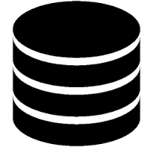

**Executioner**

**HP ALM**

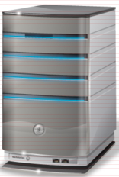

**ALM, Test Utility**

**JRE**

**Jenkins Server**

**Test Database**

**JRE**

**Test Utility**



**Jenkins**

**GitHub Apps**

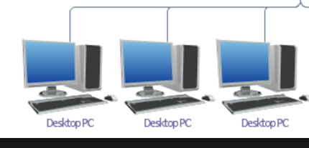

**Maven**

**Jenkins Slaves**



**Eclipse**



**Eclipse**

**Developer Workstations**

**Developer**

**Maven**

**Maven**

**GitHub Framework**



**Artifactory Server**

1. The Automation Developer on the Developer workstations uses the Test Utility to create test cases, components, objects which are stored in the Test Database
2. The Automation Developer uses Eclipse to build any custom Application Java code if needed and to unit test and debug and to checkin and checkout code to GitHub Apps repositories.
3. The Architect uses Eclipse to create and maintain Framework Java code and to checkin and checkout code to GitHub Framework repository.
4. The Architect users Maven to build the Framework JAR file and deploy it to the Artifactory Server.
5. The Executioner creates, configures, maintains and kicks off Jenkins jobs on the Jenkins Server to execute the test suites.
6. The Jenkins job instructs the Jenkins slave to pull down the Framework JAR file from the Artifactory Server using Maven.
7. The Jenkins job instructs the Jenkins slave to pull down and build the Application JAR file from the GitHub Apps repository for the application configured.
8. The Jenkins job then executes that Application JAR file for the configured Application using the JRE on the Jenkins slave machine for the test cases configured in the Execution Parms per application as defined in the Test Database.
9. During execution, the HP ALM database is updated with the test case status.
10. Test case reporting is performed using HP ALM reporting or the Test Utility reports.